Bella Beat Smart Device Data Analysis

**Introduction**

Bellabeat is a high-tech wellness company that designs products to help women track their health and wellness.

This report presents an in-depth analysis of Fitbit data to uncovert user behavior, focusing on activity levels, sleep patterns, calorie burn, and weight management.

The goal is to provide insights that can guide Bellabeat's marketing strategy and help enhance their product offering.

**Data source used**

GitHub – Databes

Spreadsheet – tool used to analyse data.

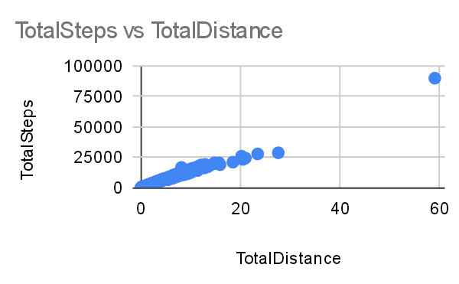The graph above representing the total steps taken daily and versus total distance, which indicating the increasing number of steps and as well for distance this resulting in coloration.

This indicating that 75000 steps taken resulting to 60 Mitres distance which emphasises health to a human body system.

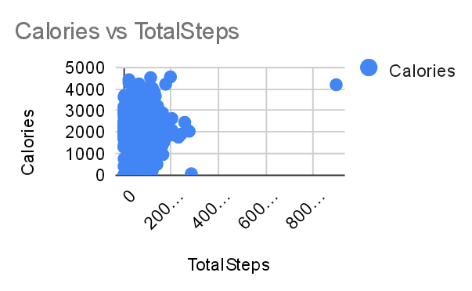The above graph representing the total steps taken against the burn of calories. This means the more calories are burnt when the more steps are taken e.g 800 steps taken resulting to burn estimation of 4000 calories, therefore Bella Beat should emphasise the use of its products to its customers since it has been identified the need and use of Bella Beat products for better health.

**Recommendation**

* Bella beat should emphasise more training challenges and competitions to introduce new members and or existing members to exciting opportunities to excesize using smart technology equipment’s for their healthiness.